**OS CH3 PPT Exercise Answer**

1. **When a process creates a new process using the fork() operation, which of the following states is shared between the parent process and the child process?**

* **Stack**
* **Heap**
* **Shared memory segments**

Answer:

Stack & Heap 都是每個程序獨自擁有而Share memory segment 會去複製 Steak 和 Heap 的東西，然後去製作新的

1. **Some computer systems provide multiple register sets. Describe what happens when a context switch occurs if the new context is already loaded into one of the register sets. What happens if the new context is in memory rather than in a register set and all the register sets are in use?**

Answer:

如果已經載入到register set, 則CPU 只要將 current - register - set 的pointer 指向新的就好，花費時間少；如果是在memory 內的話，則需要先選擇一個memory 並且將context 移過去，然後再從memory中載入進register set, 比較起來直接存在 instruction set 比存在memory 裡的快一些，但這些還是取決於如何選擇替代的victim

1. Describe the actions taken by a kernel to context switch between process?

Answer

在正常狀況下，OS必須儲存正在執行的Process 和回復原本排定行程的狀態來執行下一個process，保存process的狀態通常都包含CPU 暫存器和memory allocation。Context switch 必須執行許多特別的結構，像是刷新資料和指令的快取

1. Including the initial parent process, how many processes are created by the program shown below?

#include <stdio.h>

#include <unistd.h>

int main() {

for (int i = 0; i < 4; i++)

fork();

return 0;

}

Answer

畫圖Fork(); Fork(); Fork(); Fork();

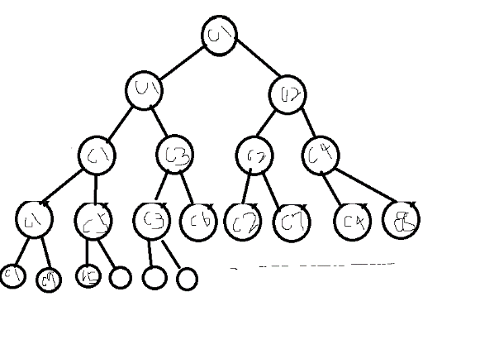

1. Explain the circumstances under which the line of code marked printf("LINE J"); will be reached.

#include <sys/types.h>

#include <stdio.h>

#include <unistd.h>

int main() {

pid_t pid;

pid = fork(); //fork a child process

if (pid < 0) { //error occurred

fprintf(stderr, “Fork Failed”); return 1;

}

else if (pid == 0) { //child process

execlp(“/bin/ls”,“ls”,NULL);

printf(“LINE J”); }

else { //parent process

wait(NULL); // parent waits for child complete

printf("Child Complete");

}

}

Answer

如果execlp()執行成功則永遠都不會print出，因為如果有成功執行則會覆蓋掉後面的程序，所以反之則會輸出。

1. Explain the role of the init (or systemd) process on UNIX and Linux systems in regard to process termination

Answer

init 是 parent process，所以當有 orphan 的情況出現時，呼叫 init去讓child process 有 parent process去完成該process